.RTF TEMPLATE FOR EXTENDED ABSTRACT FOR “PRIMO CONGRESSO NAZIONALE DI BIOINGEGNERIA”

A. Author ^{A, B}, B. Author ^{B}, C. Author ^{B}, D. Author ^{B}
ª Department or Laboratory name, Institution name, Town, Country
^{b} Department or Laboratory name, Institution name, Town, Country

INTRODUCTION
The extended abstract is a summary, which outlines the work to be reported, and includes as many of the results as possible. The maximum length of the abstract is two pages.
The inclusion of figures and tables is strongly recommended.
The abstract should be submitted in PDF format as soon as possible, but not later than April 15, 2008.
The abstract can be submitted only via email to the following email address:
CongressoGNB2008@sssup.it
The following instructions should be followed for preparing the abstracts:
- Page Size: A4 (297mm x 210mm – 11.69” x 8.27”)
- Length: Abstracts should NOT be more than two pages in length.
- One Column Format: The text should be typed in one single column format as shown in this template.
- Title: Center the title of the paper at the top of the page. It should be typed in capital letters. Use bold, 12 pt Arial font or equivalent for the title.
- Author names: list the name(s) of all of the author(s) in a single line, separated by commas. Use bold, 11 pt Times New Roman font.
- Address: In the space provided, give the business affiliation, address of the authors. Use italic, 11 pt Times New Roman font.
- Text: Skip two lines and start the text. The text must be neat and single-spaced. Use 11 pt Times New Roman font for the text.
- Major Headings: Use bold, 11 pt Times New Roman font to type the major headings. It should be typed in capital letters.
- Figures: Figures or Tables can be incorporated electronically in the Extended Abstract (please, choose the most significant one/s). Each figure should be accompanied by a caption.
- Lettering: All lettering of the text should not be smaller than 11 points. The font for the text is Times New Roman.
- References: List and number all bibliographical references at the end of the document in order of appearance in the paper text. When referring to them in the text, type the corresponding reference number in square brackets as shown at the end of this sentence [1].
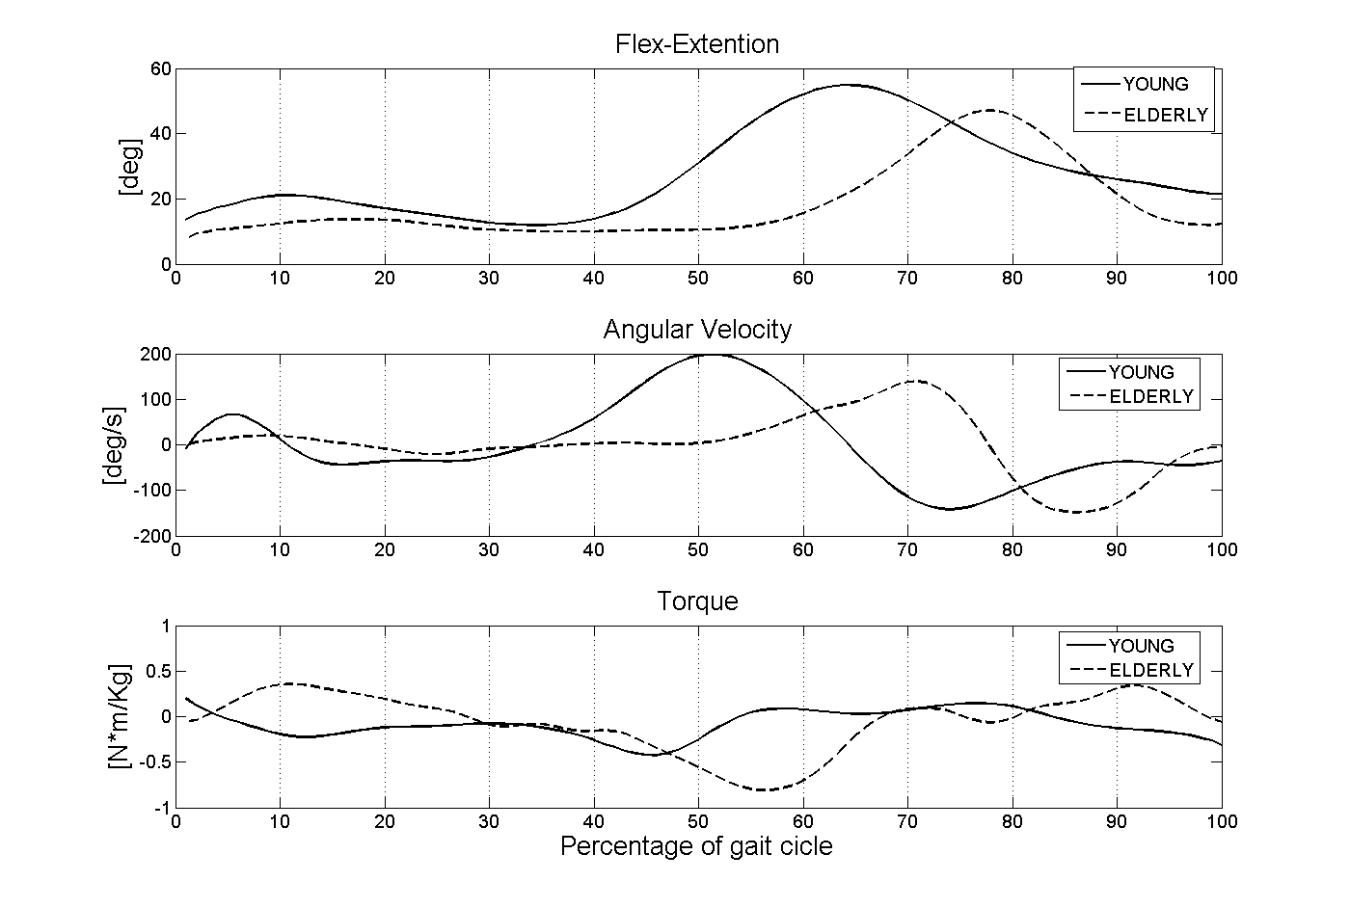
- Language: Document must be in English, using only standard symbols and abbreviations in the text and illustrations.
Fig.1 This is a typical figure with caption.

METHODS

RESULTS AND DISCUSSION

REFERENCES
[1] Aoyagiet Y. et al., Sport Med., 1992, 14: 376-396.
[2] van Bemmel T. et al., Journal of Clinical Epidemiology, 2005, 58: 63-67.
[3] Lay A. N. et al., Journal of Biomechanics, 2006, 39: 1621-1628.

